Methyl-cellulose

Group 22 – Bethany Mulliner

|  |  |
| --- | --- |
| Topic | Page Number |
| Title Page | 1 |
| Contents Page | 2 |
| Design Brief | 3 |
| Block Diagram | 3 |
| Process Flow Diagram | 3 |
| Process Description | 4 |
| Material Balance | 4 |
| Energy Balance | 4 |
| Physical Properties & Limitations | 5 |
| Safety & Environmental Impacts | 6 |
| Individual Technical Section | 7 |
| References | 27 |

**Contents**

**Design Brief**

You are to design a 100,000 tonnes per annum plant producing methyl-cellulose. Before the methylation reaction can take place, the cellulose fibres must be swollen using NaOH. This is called mercerisation. NaOH is supplied as a 5M solution at and no more than 20˚C. The aqueous NaCl solution is produced from the pure components in a continuous mixing tank. It is then passed through a heat exchanger and stored in a storage tank. Consider that the water temperature could vary between 12 and 18˚C. Standard utilities on site are process water at 10˚C, saturated steam at 150 barg, cooling water at 10˚C, instrument air at 6 barg and condensate water at 1 barg. (Heriot-Watt University, 2018)

**Block Diagram**

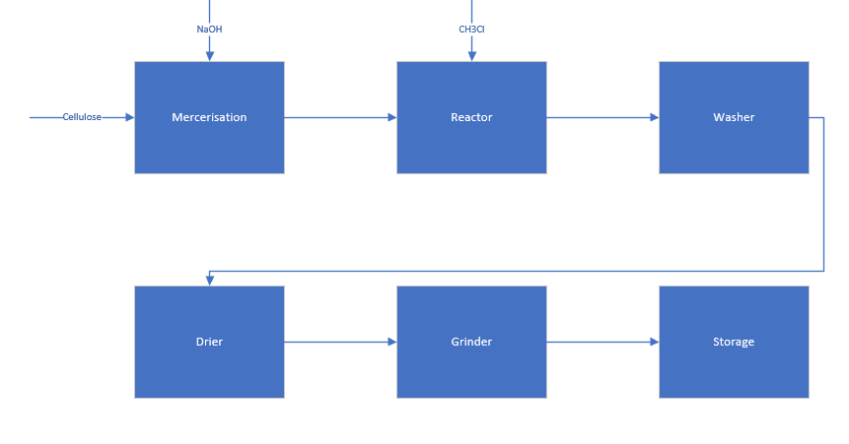

**Process Flow Diagram**

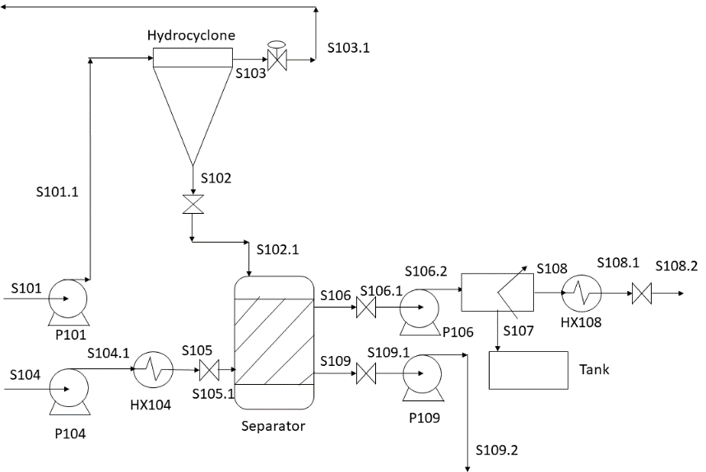

**Process Description**

My chosen section of the process to design is the separation of the product stream from the reactor using a hydrocyclone and a washer. The product stream containing methyl-cellulose exits the reactor in S101 and is pumped to a hydrocyclone to separate the methyl-cellulose and sodium chloride from excess methyl chloride. The excess methyl chloride is recycled for reuse in the reactor in S103. The methyl-cellulose and sodium chloride then enter a washer by S102, where they are mixed with large amounts of water from S105 in order for the sodium chloride to completely dissolve. The sodium chloride solution is pumped out of the reactor in the top stream (S106), before entering a dryer to remove the majority of the water. The sodium chloride is then stored in a tank before being sold as a by-product of the process. The bottom stream (S109) containing the methyl-cellulose and water is pumped from the washer to a dryer.

**Material Balance**





**Energy Balance**





**Physical Properties & Limitations**

Heat Exchanger, Tube Side:

|  |  |  |  |  |
| --- | --- | --- | --- | --- |
| Property | Unit | Inlet | Outlet | Mean |
| Temperature | ˚C | 10 | 80 | 45 |
| Specific Heat | kJ/kg˚C | 4.1926 | 4.1974 | 4.195 |
| Thermal Conductivity | W/m˚C | 0.5868 | 0.6698 | 0.6283 |
| Density | kg/m3 | 999.699 | 971.799 | 985.749 |
| Viscosity | mNs/m2 | 1.3038 | 0.3518 | 0.8278 |

Heat Exchanger, Shell Side:

|  |  |  |  |  |
| --- | --- | --- | --- | --- |
| Property | Unit | Inlet | Outlet | Mean |
| Temperature | ˚C | 100 | 80 | 90 |
| Specific Heat | kJ/kg˚C | 4.217 | 4.1974 | 4.2072 |
| Thermal Conductivity | W/m˚C | 0.68 | 0.6698 | 0.6749 |
| Density | kg/m3 | 958.365 | 971.799 | 965.082 |
| Viscosity | mNs/m2 | 0.279 | 0.3518 | 0.3154 |

Pump:

|  |  |
| --- | --- |
| Properties | Value |
| Pressure (Pa) | |  |  | | --- | --- | | S106.1 | S106.2 | | 1699934 | 2500000 | |
| Temperature (˚C) | 80 |
| Density (kg/m3) | 1026.4 |
| Viscosity (Ns/m2) | ~0.6 |
| Velocity (m/s) | 0.12 |







Where Cp = A+BT+CT2+DT3+ET4+FT5+GT6



The washer and the hydrocyclone were both assumed to be 100% efficient, the dryer was assumed to be 97% efficient.

**Safety & Environmental Impacts –Bethany Mulliner**

S101, the hydrocyclone and S103 all contain methyl chloride, which is toxic even in very small amounts and thought to be a carcinogen. Therefore, all pipes and vessels containing methyl chloride should be checked regularly for any leaks or signs of corrosion. These areas should also be well-ventilated to avoid the accumulation of methyl-chloride in the event of a leak. Methyl-chloride is also highly flammable and explosive, especially in the presence of oxygen, therefore, there should be no open flames or sparking equipment or lighting within the vicinity of any equipment dealing with methyl-chloride. In the event of a leak or a fire, all process-critical personnel within the vicinity should don respirators and protective clothing. All others should evacuate. To signal a leak or fire to site personnel, an alarm system will be used. (IPCS INCHEM, 2015)

Methyl chloride is also thought to be toxic to wildlife and is considered a greenhouse gas. Therefore, utmost care should be taken to avoid all possible leakages in order to avoid damaging the local ecosystem and atmosphere. (IPCS INCHEM, 2015), (McCulloch, et al., 1999)

Gate valves are fitted before and after all streams on the washer in order for it to be isolated if necessary. Non-return valves as well as pressure relief valves would be fitted after all pumps in order to ensure no backflow occurs and any excess pressure can be vented in case of an emergency.

The majority of process streams are at high temperatures and pressures, and therefore would be dangerous to be exposed to. Hence, PPE should be worn at all times (protective glasses, hard hat, overalls and steel-toed boots at a minimum.

For the pumps, a safety factor of 25% was taken into account in order to avoid an emergency if the flowrate suddenly increased.

**Individual Technical Section – Bethany Mulliner**

**Heat Exchanger Design**

Introduction

The heat exchanger I have designed is situated on an on-site cold-water line in order to heat 35.35 kg/s of water from 10˚C to 80˚C in order for it to be used in the separator.

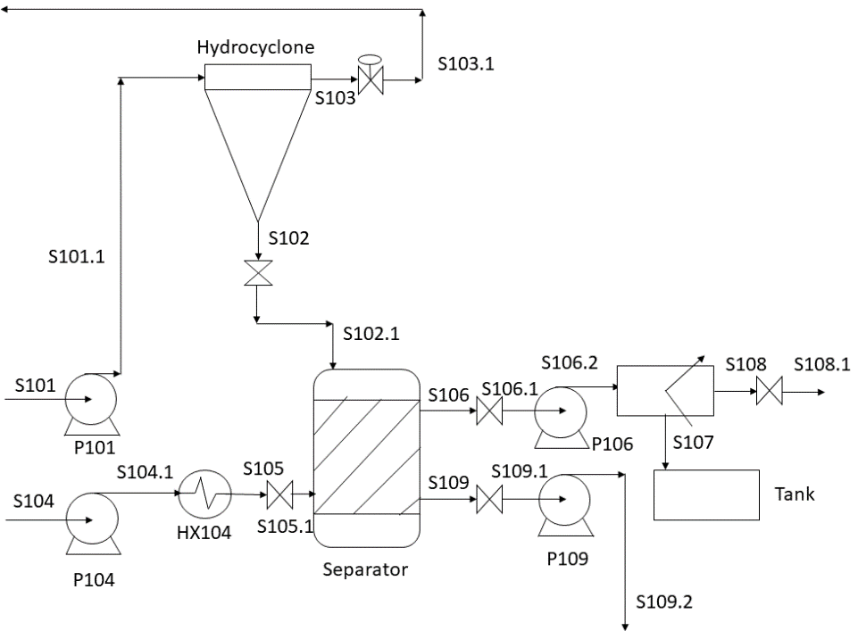

Design Details

The chosen design for this heat exchanger was a split-ring floating-head shell and tube heat exchanger, as this is a very common variety of heat exchanger to use for heating water and is easily serviced. The process water is from the on-site utility at 10˚C and has been assumed to be compressed to a pressure of 1MPa. The process water exits the tube-side of the heat exchanger at 80˚C. The shell-side of the exchanger contains the water used for heating, which has been assumed to also be from the on-site utility, heated to a temperature of 100˚C and compressed to a pressure of 1MPa. The heating water exits the shell-side of the heat exchanger also at 80˚C. The choice was made to put the water to be heated in the tube-side of the exchanger, as it had a higher velocity than the heating water.

In order to minimize flowrate and maximize heat transfer on the tube-side of the exchanger, the optimal tube size was determined to be carbon-steel tubes with an external diameter of 50mm and a wall thickness of 3.4mm. To further minimize the tube-size flowrate, 10 passes were used. A pipe length of 7.32m was chosen to maximize heat transfer, and because it is a standard size of pipe. Carbon-steel was chosen as the material for both the tubes and the shell, as the fluid in both is water, which is non-corrosive, and because carbon-steel is relatively inexpensive.

To increase the rate of heat transfer, a triangular pitch arrangement was used over a square arrangement. Although this can cause a higher tube-side pressure-drop, the effects were found to be minimal. The highest allowable pressure-drop for both the tube-side and the shell-side of the exchanger was 35kPa. (Sinnot & Towler, 12.7.4. Pressure Drop, 2017)

Diagram

Tube Side

* Water
* 35.35 kg/s
* 1 MPa
* 10˚C

Shell Side

* Heating Water
* 125 kg/s
* 1 MPa
* 80˚C

Shell Side

* Heating Water
* 125 kg/s
* 1 MPa
* 100˚C

Tube Side

* Water
* 35.35 kg/s
* 1 MPa
* 80˚C

Specifications



Physical Properties

Due to the required temperature values often not having entries in literature, interpolation was used to obtain the values where needed. All values from Perry’s. (Perry & Green, 1997)

Tube Side:

|  |  |  |  |  |
| --- | --- | --- | --- | --- |
| Property | Unit | Inlet | Outlet | Mean |
| Temperature | ˚C | 10 | 80 | 45 |
| Specific Heat | kJ/kg˚C | 4.1926 | 4.1974 | 4.195 |
| Thermal Conductivity | W/m˚C | 0.5868 | 0.6698 | 0.6283 |
| Density | kg/m3 | 999.699 | 971.799 | 985.749 |
| Viscosity | mNs/m2 | 1.3038 | 0.3518 | 0.8278 |

Shell Side:

|  |  |  |  |  |
| --- | --- | --- | --- | --- |
| Property | Unit | Inlet | Outlet | Mean |
| Temperature | ˚C | 100 | 80 | 90 |
| Specific Heat | kJ/kg˚C | 4.217 | 4.1974 | 4.2072 |
| Thermal Conductivity | W/m˚C | 0.68 | 0.6698 | 0.6749 |
| Density | kg/m3 | 958.365 | 971.799 | 965.082 |
| Viscosity | mNs/m2 | 0.279 | 0.3518 | 0.3154 |

Calculations

For designing the heat exchanger, the procedure described in Chemical Engineering Design (Sinnot & Towler, 12.2. Basic Design Procedure and Theory, 2017) was used. A time basis of one second is assumed for all calculations.

Step 1: Define the Duty

The heat exchanger duty is found by:

Where:

Q – Heat exchanger duty (kW)

– Tube-side stream flowrate (kg/s)

-Mean tube-side stream specific heat capacity (kJ/kg˚C)

ΔT – Tube-side stream temperature change (˚C)

Hence:

From this, the required shell-side mass flow could be calculated:

Step 2: Collect Physical Properties

This was described in **Physical Properties**.

Step 3: Exchanger Type

This was described in **Design Details**.

Step 4: Select a Trial Value for the Overall Coefficient, U

As both the hot and cold fluids are water and because the heat exchanger is of the shell and tube variety, a trial value for U of 1150 W/m2˚C was selected, as this is the midpoint of the stated typical range. (Sinnot & Towler, Table 12.1. Typical Overall Coefficients, 2017)

Step 5: Calculate the Mean Temperature Difference, ΔTm

The logarithmic mean temperature difference is given by:

Where:

ΔTlm – Logarithmic mean temperature difference (˚C)

T1 – Hot fluid inlet temperature (˚C)

T2 – Hot fluid outlet temperature (˚C)

t1 – Cold fluid inlet temperature (˚C)

t2 – Cold fluid outlet temperature (˚C)

Hence:

The true mean temperature difference, ΔTm, could then be calculated:

Where:

Ft – Temperature correction factor

The temperature correction factor is a correlation between two dimensionless temperature ratios:

Therefore, Ft could be estimated as 0.85 from a graphical correlation.

Hence:

(Sinnot & Towler, 12.6. Mean Temperature Difference (Temperature Driving Force), 2017)

Step 6: Calculate the Heat Transfer Area

The equation for heat transfer is given by:

Where:

Q – Heat transferred per unit time (W)

U – Overall heat transfer coefficient (W/m2˚C)

A – Heat transfer area (m2)

ΔTm – Mean temperature difference (˚C)

Hence:

(Sinnot & Towler, 12.2. Basic Design Procedure and Theory, 2017)

Step 7: Exchanger Layout

This was discussed to an extent in **Design Details**. In summary, carbon-steel tubes with a diameter of 50mm and a wall thickness of 3.4mm were used. The inner diameter and tube pitch could then be calculated:

Where:

di – Tube Inner diameter (mm)

do – Tube Outer diameter (mm)

wt – Tube Wall thickness (mm)

Hence:

(Sinnot & Towler, 12.5.2. Tubes, 2017)

Where:

pt – Tube pitch (mm)

do – Tube Outer diameter (mm)

To calculate the number of tubes needed, a goal seek method was used in Excel. (Michaloudis, 2017)

Firstly, the area of each tube had to be calculated:

Where:

At – Area of one tube (m2)

Do – Tube Outer diameter (m)

L – Pipe length

Hence:

By storing the number of tubes in a new cell, the formula becomes:

Where:

A - Heat transfer area

x – Number of tubes

Goal seek is then used to calculate the number of tubes needed, by using a formula to set a new cell containing A to the same value as the calculate heat transfer area from **Step 6** by altering the cell containing the number of tubes. Using this formula, the number of tubes is found to be approximately 268.

The tube-side fluid velocity can now be calculated:

Where:

vt – Tube-side velocity (m/s)

- Tube-side flowrate (kg/s)

r – Tube radius (m)

x – Number of tubes

n – Number of passes

Hence:

This is an acceptable value as it is between 1.5 and 2.5 m/s. (Sinnot & Towler, 12.7.2. Shell and Tube Fluid Velocities, 2017)

From these calculated results, the bundle diameter could be calculated:

Where:

Db – Bundle diameter (mm)

Do – Tube outer diameter (mm)

Nt – Number of tubes

K1, n1 – Constants

The included constants table in Chemical Engineering Design (Sinnot & Towler, Table 12.4. Constants for Use in Equation 12.3, 2017) only includes values for up to 8 passes, therefore, this table has been extrapolated upon in order to obtain estimations for constants for 10 passes.

From this, we find:

Hence:

(Sinnot & Towler, 12.5.4. Tube-sheet Layout (Tube Count), 2017)

This allowed the shell thickness to be estimated and hence the external shell diameter to be calculated. The shell thickness was extrapolated from a graph found in Chemical Engineering Design (Sinnot & Towler, Figure 12.12. Shell-bundle clearance, 2017) to be approximately 85mm.

Where:

Ds – Shell Diameter (m)

Db – Bundle Diameter (m)

st – Shell thickness (m)

Hence:

The baffle spacing was then calculated according to:

(Sinnot & Towler, 12.5.7. Baffles, 2017)

Where:

lB – Baffle spacing (m)

Ds – Shell Diameter (m)

Hence:

Step 8: Calculate the Individual Coefficients

For the tube-side, since the fluid is water, only one equation is needed to calculate the heat transfer coefficient:

(Sinnot & Towler, 12.8.1. Heat Transfer, 2017)

Where:

hi – Inside coefficient for water (W/m2˚C)

t – Mean water temperature (˚C)

ut - Water velocity (m/s)

di – Tube inner diameter (mm)

Hence:

W/m2˚C

For the shell-side, the situation is slightly more complicated. We must use Kern’s method in order to reasonably predict the heat transfer coefficient. (Sinnot & Towler, 12.9.3. Kern's Method, 2017) First, the cross-flow area must be calculated:

Where:

As – Cross-flow area (m2)

pt – Tube pitch (m)

do – Tube external diameter (m)

Ds - Shell internal diameter (m)

lB – Baffle spacing (m)

Hence:

m2

Next, the shell-side mass velocity and linear velocity can be calculated:

Where:

Gs – Shell-side mass velocity (m/s)

Ws – Shell-side fluid flow (kg/s)

As – Cross-flow area (m2)

us – Linear velocity (m/s)

ρ – Mean shell-side fluid velocity (kg/m3)

Hence:

This is an acceptable value as it is between 0.3 and 1m/s. (Sinnot & Towler, 12.7.2. Shell and Tube Fluid Velocities, 2017)

Next, the shell-side equivalent diameter for a triangular-pitch arrangement can be calculated:

Where:

de – Shell-side equivalent diameter (m)

do – Tube external diameter (m)

pt – Tube pitch (m)

Hence:

Next, the Reynolds and Prandtl numbers must be calculated:

Where:

Re – Reynolds Number

Gs – Shell-side velocity (m/s)

de – Equivalent diameter (m)

μ – Mean shell-side fluid viscosity (Ns/m2)

Pr – Prandtl Number

Cp – Mean shell-side specific heat capacity (kJ/kg˚C)

kf – Mean shell-side thermal conductivity (W/mK)

From these, using the suitable chart (Sinnot & Towler, Figure 12.29. Shell-side heat transfer factors, segmented baffles, 2017) and assuming a baffle cut of 25%, we can estimate the heat transfer factor jh to be .

Finally, the shell-side heat transfer coefficient can be calculated:

Where:

ho – Shell-side heat transfer coefficient (W/m2˚C)

kf – Mean shell-side thermal conductivity (W/mK)

de – Shell-side equivalent diameter (m)

jh – Heat transfer factor

Re – Reynolds Number

Pr – Prandtl Number

W/m2˚C

Step 9: Calculate the Overall Coefficient

Now, the overall coefficient can be calculated:

Where:

Uo – Overall heat transfer coefficient (W/m2˚C)

ho – Outside heat transfer coefficient (W/m2˚C)

hod – Outside dirt coefficient (W/m2˚C)

hi – Inside heat transfer coefficient (W/m2˚C)

hid – Inside dirt coefficient (W/m2˚C)

do – Tube external diameter (m)

di – Tube internal diameter (m)

kw – Tube wall material thermal conductivity (W/mK)

Assuming that the water used in the exchanger is from a town source, an inner and outer dirt coefficient of 3000 W/m2˚C was assumed. (Sinnot & Towler, 12.4. Fouling Factors (Dirt Factors), 2017) The average thermal conductivity of carbon steel was found to be 45 W/mK. (Perry & Green, 1997)

Hence:

W/m2˚C

This is within 30% of the original value, therefore the design is acceptable. (Sinnot & Towler, Figure 12.3.1. Design procedure for shell and tube heat exchangers, 2017)

Step 10: Calculate the exchanger pressure drop

For the tube-side pressure drop to be calculated, we must first calculate the tube-side fluid Reynolds number:

Where:

Re – Reynolds Number

ρ – Average tube-side fluid density (kg/m3)

u – Tube-side fluid velocity (m/s)

d – Tube inner diameter (m)

μ – Average tube-side fluid viscosity (Ns/m2)

Hence:

From this, the tube-side friction factor, jf, could be estimated as . (Sinnot & Towler, Figure 12.24. Tube-side friction factors, 2017)

The tube-side pressure drop can now be calculated:

Where:

ΔPt – Tube-side pressure drop (Pa)

Np – Number of tube-side passes

jf – Tube-side friction factor

L – Tube length (m)

di – Tube inner diameter (m)

ρ – Average tube-side fluid density (kg/m3)

ut – Average tube-side fluid velocity (m/s)

Hence:

This is within 10% of the original pressure, therefore, the pressure drop is acceptable.

(Sinnot & Towler, 12.8.2. Tube-side Pressure Drop, 2017)

The shell-side pressure drop can be calculated through the final step of Kern’s Method. (Sinnot & Towler, 12.9.3. Kern's Method, 2017) For the previously calculated shell-side Reynolds number and assuming a baffle cut of 25%, we can estimate the shell-side friction factor as . (Sinnot & Towler, Figure 12.30. Shell-side friction factor, segmented baffles, 2017)

The shell-side pressure drop can now be calculated:

Where:

ΔPs – Shell-side pressure drop (Pa)

jf – Shell-side friction factor

Ds – Shell inner diameter (m)

De – Shell equivalent diameter (m)

L – Tube length (m)

lB – Baffle spacing (m)

ρ – Average shell-side fluid density (kg/m3)

us – Average shell-side fluid velocity (m/s)

Hence:

Once again, this is within 10% of the original pressure, therefore, the pressure drop is acceptable.

(Sinnot & Towler, 12.9.3. Kern's Method, 2017)

(Douglas, Gasiorek, & Swaffield, 2001)

Step 11: Optimise the Design

Throughout the exchanger’s design process, many changes were procedurally made in order to optimise the design to obtain this final design.

**Pump Design**

Introduction

The pump I have designed is situated in the top stream exiting the washer in order to increase the pressure of S106 from 1.7 to 2.5 bar.

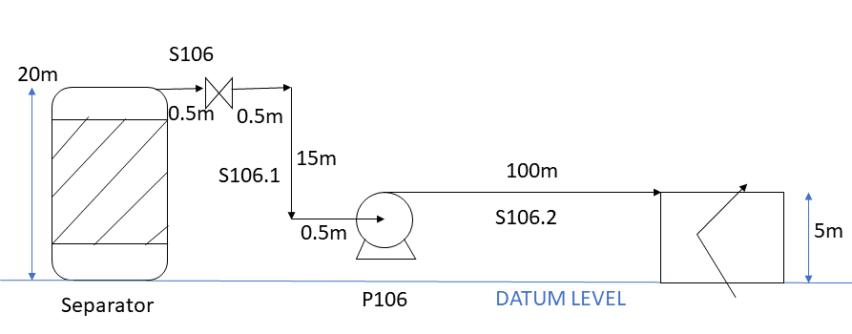

Design Details

The washer was assumed to be 20m high and S106 was assumed to exit the washer at the top. I also assumed a clearance of 1.5m between the washer and the pump was required for maintenance. The dryer was assumed to be 5m high, and S106.2 entered the dryer at the top. S106.1 and S106.2 were assumed to respectively enter and exit P106 at the same height, 5m. P106 and the dryer were assumed to be 100m apart. The pump compressed the solution to a pressure of 2.5MPa. The pipe radius was assumed to be 5”.

For safety purposes, all calculations assumed a maximum flowrate of 25% higher than the maximum calculated flowrate in order to account for a large fluctuation in flowrate.

Specifications



Physical Properties

|  |  |
| --- | --- |
| Properties | Value |
| Pressure (Pa) | |  |  | | --- | --- | | S106.1 | S106.2 | | 1699934 | 2500000 | |
| Temperature (˚C) | 80 |
| Density (kg/m3) | 1026.4 |
| Viscosity (Ns/m2) | ~0.6 |
| Velocity (m/s) | 0.12 |

(Perry & Green, 1997), (Ozbek, 2010)

Calculations

CSA and Fluid Velocity

Firstly, the cross-sectional area (CSA) of the pipe must be calculated using the aforementioned assumptions:

Where:

CSA – Cross-sectional area (m2)

r – Pipe radius (m)

Hence:

m2

The fluid velocity can then be calculated:

Where:

v- Fluid velocity (m/s)

q – Fluid flowrate (m3/s)

A – Cross-sectional area (m2)

Hence:

(Douglas, Gasiorek, & Swaffield, 2001)

Pressure Losses

Steel was chosen as the material for the piping, as it will experience minimal corrosion whilst being relatively inexpensive. This gave an absolute roughness value of ε=0.046mm. (Sinnot & Towler, Table 5.2. Pipe Roughness, 2017)

To find the pressure drop, the Reynolds number was first calculated:

Where:

Re – Reynolds Number

ρ – Fluid density (kg/m3)

u – Fluid velocity (m/s)

d – Pipe diameter (m)

μ – Fluid viscosity (Ns/m2)

Hence:

The relative roughness of the pipe was also calculated:

Where:

ε – Absolute roughness (m)

d – Pipe diameter (m)

Hence:

From these results, the friction factor, f, can be found from a chart to be . (Sinnot & Towler, Figure 5.11. Pipe friction versus Reynolds number and relative roughness, 2017)

To calculate the pressure drop the following formulae are used:

Where:

ΔPf – Pressure loss due to friction (Pa)

f – Friction factor

L – Length of straight pipe (m)

di – Interior pipe diameter

– Equivalent pipe diameters

ρ – Fluid density (kg/m3)

u – Fluid velocity (m/s)

Where:

hs – Required suction head (m)

Ps – Suction-side fluid pressure (Pa)

ρ – Fluid density (kg/m3)

g – Acceleration due to gravity (9.81m/s2)

Zs – Hydrostatic suction head (m)

hfs – Suction head due to friction (m)

hd – Required discharge head (m)

Pd – Discharge-side fluid pressure (Pa)

Zd – Hydrostatic discharge head (m)

hfd – Discharge head due to friction (m)

Hence, for the suction side:

The length of straight pipe on the suction side is 16.5m. The number if equivalent pipe diameters for the suction side is:

|  |  |  |
| --- | --- | --- |
| Fitting | Quantity |  |
| Sharp reduction (tank outlet) | 1 | 25 |
| Gate valve, fully open | 1 | 7.5 |
| 90˚ standard radius elbow | 2 | 70 |
| Total |  | 102.5 |

(Sinnot & Towler, Table 5.3. Pressure Loss in Pipe Fittings and Valves (for Turbulent Flow), 2017)

Hence:

(Douglas, Gasiorek, & Swaffield, 2001)

And hence, for the discharge side:

|  |  |  |
| --- | --- | --- |
| Fitting | Quantity |  |
| Sharp reduction (tank outlet) | 1 | 25 |
| Sudden expansion (tank inlet) | 1 | 50 |
| Total |  | 75 |

(Sinnot & Towler, Table 5.3. Pressure Loss in Pipe Fittings and Valves (for Turbulent Flow), 2017)

(Douglas, Gasiorek, & Swaffield, 2001)

Now, the overall pump head and pressure loss can be calculated:

Where:

Δhp – Pump head (m)

hd – Discharge head (m)

hs – Suction head (m)

Hence:

Where:

ΔhT – Pump pressure drop (Pa)

ρ – Fluid density (kg/m3)

g – Acceleration due to gravity (9.81m/s2)

Δhp – Pump head (m)

Hence:

Power

Using these obtained results, we can estimate the efficiency of the pump to be approximately 50%. (Sinnot & Towler, Figure 5.14. Pump characteristic for a range of impeller sizes, 2017) This allows us to determine that a 150mm impeller should be used.

The theoretical minimum required hydraulic power can be calculated from:

Where:

- Theoretical minimum hydraulic power (W)

ΔPT – Pump pressure loss (Pa)

Q – Volumetric flow rate (m3/s)

Hence:

From this, the actual required pump power can be calculated:

Where:

– Actual required pump input power (W)

- Theoretical minimum hydraulic power (W)

η – Pump efficiency

Hence:

From literature, the saturated vapour pressure was found to be approximately 20psi, or 138kPa. (Dittman, 1977)

From this, the available and required NPSH could be calculated:

Where:

NPSHA – Available net positive suction head (m)

Ps – Suction pressure (Pa)

Psat – Saturated vapour pressure (Pa)

ρ – Fluid density (kg/m3)

g – Acceleration due to gravity (9.81m/s2)

Zs – Suction-side hydrostatic head (m)

hfs – Suction head due to friction (m)

NPSHR – Required net positive suction head (m)

Hence:

This is satisfactory, as NPSHA>>NPSHR. (Douglas, Gasiorek, & Swaffield, 2001) (Sinnot & Towler, Chemical Engineering Design (5th Edition), 2017)

Miscellaneous

From literature, we can also determine the pump to be single-stage at 3500rpm. (Sinnot & Towler, Figure 5.10. Centrifugal pump selection guide, 2017)

This allows us to calculate the impeller specific speed:

Where:

N’s – Impeller specific speed (rpmgal/ftmin)

N’ – Revolutions per minute (rpm)

Q – Volumetric flowrate (US gal/min)

h – Head (ft)

Hence:

(Sinnot & Towler, 5.4 Pumps and Compressors, 2017)

A suitable existing pump design for this application is the MP Pumps CHEMFLO 7, as the head is within the range of 160-280 ft and the volumetric flowrate is within the range of 0-200 US gal/min, and the pump rpm is 3500rpm with a varying impeller size.

A performance curve for this pump is shown below:

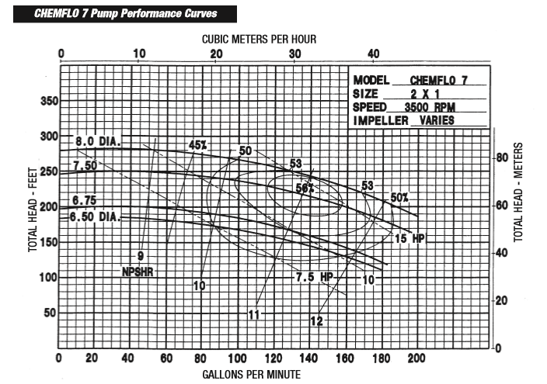

(MP Pumps Europe)

**References**

Dittman, G. L. (1977). *Calculation of Brine Properties.* Livermore: Lawrence Livermore Laboratory.

Douglas, J. F., Gasiorek, J. M., & Swaffield, J. A. (2001). *Fluid Mechanics (4th Edition).* Harlow: Pearson.

Heriot-Watt University. (2018). *Group 22 Design Brief: Methyl-cellulose.* Edinburgh.

IPCS INCHEM. (2015, June). *METHYL CHLORIDE*. Retrieved from INCHEM: http://www.inchem.org/documents/icsc/icsc/eics0419.htm

McCulloch, A., Aucott, M. L., Benkovitz, C. M., Graedel, T. E., Kleiman, G., Midgley, P. M., & Li, Y.-F. (1999). Global emissions of hydrogen chloride and chloromethane from coal combustion, incineration and industrial activities: Reactive Chlorine Emissions Inventory . *Journal of Geophysical Research, Vol. 104 No. D7*, 8391-8403.

Michaloudis, J. (2017). *Use Excel Goal Seek To Find The Formula Result You Want*. Retrieved January 15, 2018, from https://www.myexcelonline.com/blog/use-excel-goal-seek-to-find-the-formula-result-you-want/

MP Pumps Europe. (n.d.). *Industrial Catalogue.* Retrieved from MP Pumps Europe: http://www.mppumps.eu/non-html/catalog/industrial/catalog_ind_fulll.pdf

Ozbek, H. (2010). *VISCOSITY OF AQUEOUS SODIUM CHLORIDE SOLUTIONS FROM 0 - 150oC.* Berkeley: Lawrence Berkeley National Laboratory .

Perry, R. H., & Green, D. W. (1997). *Perry's Chemical Engineers' Handbook (7th Edition).* New York: McGraw-Hill.

Sinnot, R., & Towler, G. (2017). 12.2. Basic Design Procedure and Theory. In *Chemical Engineering Design (5th Edition)* (pp. 817-818). Oxford: Elsevier Ltd.

Sinnot, R., & Towler, G. (2017). 12.4. Fouling Factors (Dirt Factors). In *Chemical Engineering Design* (pp. 822-823). Oxford: Elsevier Ltd.

Sinnot, R., & Towler, G. (2017). 12.5.2. Tubes. In *Chemical Engineering Design* (pp. 827-829). Oxford: Elsevier Ltd.

Sinnot, R., & Towler, G. (2017). 12.5.4. Tube-sheet Layout (Tube Count). In *Chemical Engineering Design* (p. 832). Oxford.

Sinnot, R., & Towler, G. (2017). 12.5.7. Baffles. In *Chemical Engineering Design* (p. 834). Oxford: Elsevier Ltd.

Sinnot, R., & Towler, G. (2017). 12.6. Mean Temperature Difference (Temperature Driving Force). In *Chemical Engineering Design* (pp. 837-840). Oxford: Elsevier Ltd.

Sinnot, R., & Towler, G. (2017). 12.7.2. Shell and Tube Fluid Velocities. In *Chemical Engineering Design* (p. 843). Oxford: Elsevier Ltd.

Sinnot, R., & Towler, G. (2017). 12.7.4. Pressure Drop. In *Chemical Engineering Design (5th Edition)* (p. 844). Oxford: Elsevier Ltd.

Sinnot, R., & Towler, G. (2017). 12.8.1. Heat Transfer. In *Chemical Engineering Design* (p. 849). Oxford: Elsevier Ltd.

Sinnot, R., & Towler, G. (2017). 12.8.2. Tube-side Pressure Drop. In *Chemical Engineering Design* (pp. 849-851). Oxford: Elsevier Ltd.

Sinnot, R., & Towler, G. (2017). 12.9.3. Kern's Method. In *Chemical Engineering Design* (pp. 854-858). Oxford: Elsevier Ltd.

Sinnot, R., & Towler, G. (2017). 5.4 Pumps and Compressors. In *Chemical Engineering Design* (pp. 237-253). Oxford: Elsevier Ltd.

Sinnot, R., & Towler, G. (2017). *Chemical Engineering Design (5th Edition).* Oxford: Elsevier Ltd.

Sinnot, R., & Towler, G. (2017). Figure 12.12. Shell-bundle clearance. In *Chemical Engineering Design* (p. 831). Oxford: Elsevier Ltd.

Sinnot, R., & Towler, G. (2017). Figure 12.24. Tube-side friction factors. In *Chemical Engineering Design* (p. 851). Oxford: Elsevier Ltd.

Sinnot, R., & Towler, G. (2017). Figure 12.29. Shell-side heat transfer factors, segmented baffles. In *Chemical Engineering Design* (p. 856). Oxford: Elsevier Ltd.

Sinnot, R., & Towler, G. (2017). Figure 12.3.1. Design procedure for shell and tube heat exchangers. In *Chemical Engineering Design* (p. 868). Oxford: Elsevier Ltd.

Sinnot, R., & Towler, G. (2017). Figure 12.30. Shell-side friction factor, segmented baffles. In *Chemical Engineering Design* (p. 857). Oxford: Elsevier Ltd.

Sinnot, R., & Towler, G. (2017). Figure 5.10. Centrifugal pump selection guide. In *Chemical Engineering Design* (p. 238). Oxford: Elsevier Ltd.

Sinnot, R., & Towler, G. (2017). Figure 5.11. Pipe friction versus Reynolds number and relative roughness. In *Chemical Engineering Design* (p. 241). Oxford: Elsevier Ltd.

Sinnot, R., & Towler, G. (2017). Figure 5.14. Pump characteristic for a range of impeller sizes. In *Chemical Engineering Design* (p. 248). Oxford: Elsevier Ltd.

Sinnot, R., & Towler, G. (2017). Table 12.1. Typical Overall Coefficients. In *Chemical Engineering Design* (p. 819). Oxford: Elvesier Ltd.

Sinnot, R., & Towler, G. (2017). Table 12.4. Constants for Use in Equation 12.3. In *Chemical Engineering Design* (p. 832). Oxford: Elsevier Ltd.

Sinnot, R., & Towler, G. (2017). Table 5.2. Pipe Roughness. In *Chemical Engineering Design* (p. 242). Oxford: Elsevier Ltd.

Sinnot, R., & Towler, G. (2017). Table 5.3. Pressure Loss in Pipe Fittings and Valves (for Turbulent Flow). In *Chemical Engineering Design* (p. 243). Oxford: Elsevier Ltd.